Web Programming Technologies Machine Test - 2

March-24/ WPT/002 Time: 02:00hrs

Web Programming Technologies

Diploma in Advance Computing

March 2024

Q1. Create a user login page.

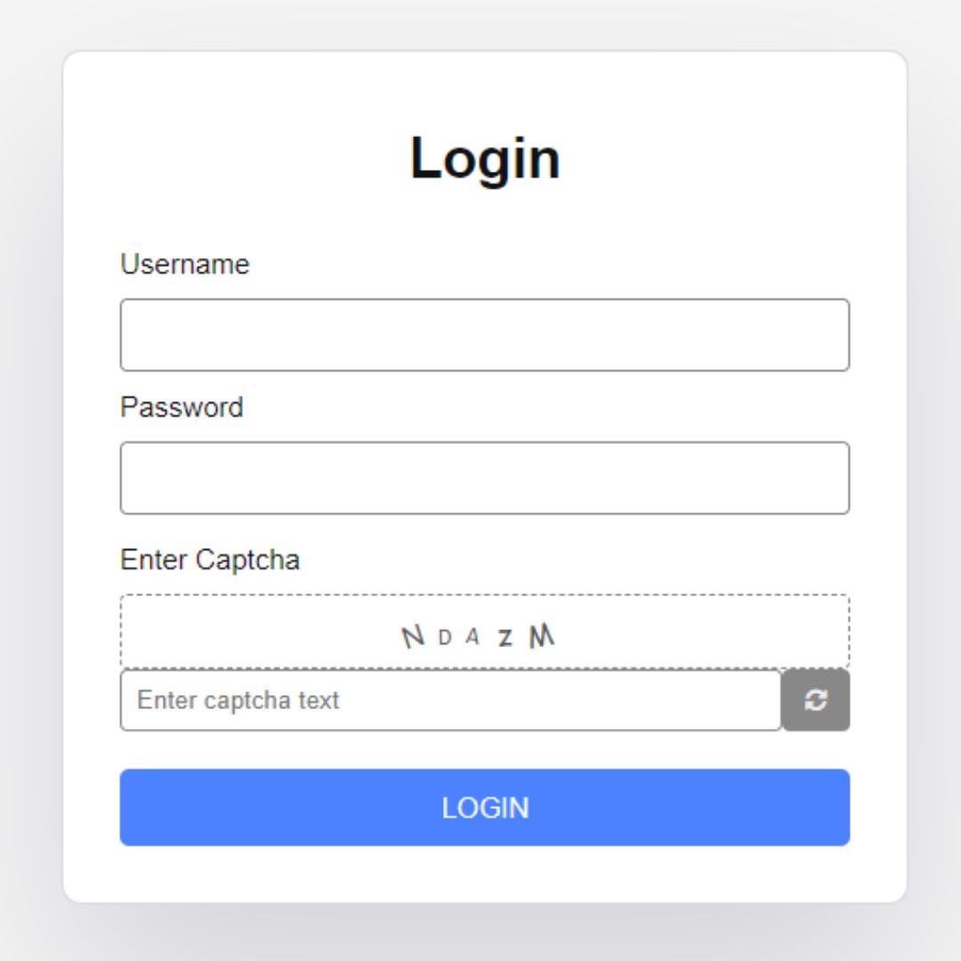

**Note: - 1. Store some predefined username and password in javascript objects.**

**2. Use random function to create captcha.**

**Test Cases.**

1. Username and Password must not be blank.
2. Username must not contain any number or special character.
3. Password must be of minimum 6 character.
4. Generated captcha and entered captcha must me same.
5. If login details are valid, then redirect to “Welcome Page”